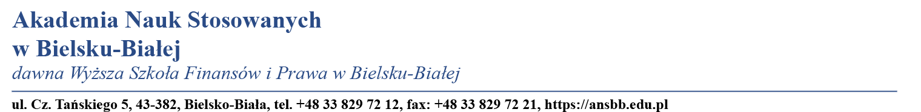
APPLICATION FORM  FOR VISITING STUDENTS  Akademia Nauk Stosowanych  (Academy of Applied Sciences) | Recent Photo
PLEASE COMPLETE THIS FORM IN CAPITAL LETTERS AND RETURN IT TO THE ADDRESS OF THE INTERNATIONAL RELATIONS OFFICE OF THE BIELSKO-BIALA SCHOOL OF FINANCES AND LAW WHERE YOU WILL SPEND YOUR ACADEMIC STAY BEFORE 15TH JUNE FOR THE 1ST SEMESTER AND 30TH NOVEMBER FOR THE 2ND SEMESTER.

Student Information: Academic Year: 20__/20__

Surname: |  |  | Name:
Permanent address:

Tel: | e-mail: |  |  | Sex:
Place and date of Birth:
Citizenship: |  | ID or passport:

Academic Information:

Home Institution:

Faculty / Department:
Degree for which you are studying:

Level: Initial Advanced Doctoral:
Study period at the Academy of Applied Sciences
From: To: Duration: months
Do you need accommodation? Yes: , No:

The University provides foreign students help with accommodation but is unable to manage rentals

If Yes, please indicate your preferred option | Residence  Shared flat with students  Dormitory

Code  (See ECTS guide) | Course title | semester  (1, 2 o Y*) | Nº créditos ECTS  credits

STUDY PROGRAMME
* 1 (FIRST SEMESTER), 2 (SECOND SEMESTER), Y (ANNUAL)

Student’s Signatura  Name:  Date: | Erasmus Contact Person  Akademia Nauk Stosowanych w Bielsku-Białej  (eng. Academy of Applied Sciences)  Name:  Date:

Prof. nadzw. dr hab. inż. Jacek Binda
Rector of the Academy of Applied Sciences
ERASMUS institutional coordinator
e-mail: jbinda@ansbb.edu.pl
Tel: +48 33 829 72 14
Fax: +48 33 829 72 21

International and Public Relations Office
dr Jolanta Kubicka
ERASMUS Departmental coordinator
e-mail: jkubicka@wsfip.edu.pl

